**DESIGN DIAGRAM :**

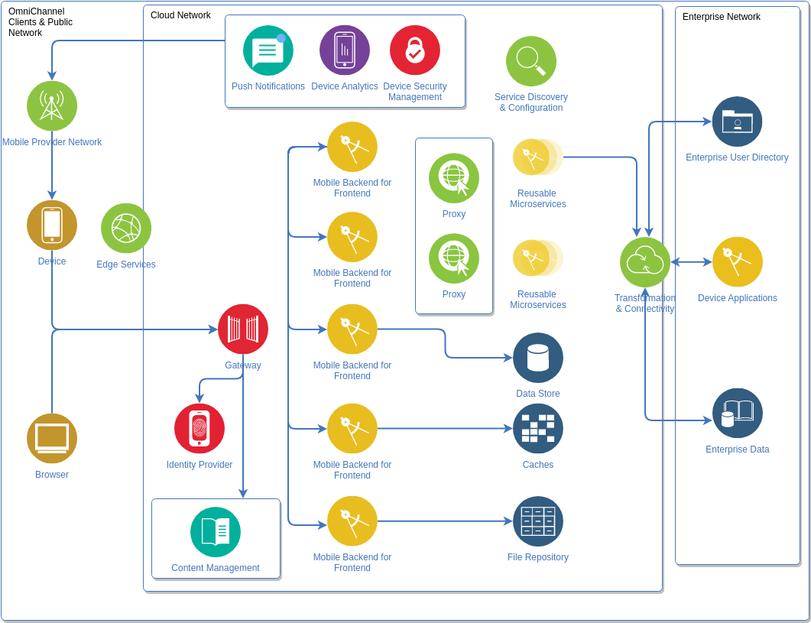

**DATASET AND PROPERTIES :**

Creating a personal blog on IBM Cloud Static Web Apps involves a series of steps from preparing your dataset and its properties, preprocessing, and feature extraction. However, IBM Cloud Static Web Apps doesn't inherently provide machine learning functionalities related to feature extraction. These can be performed using other IBM Cloud services like IBM Watson or other Machine Learning libraries in Python, JavaScript etc, before you host the site on IBM Cloud Static Web Apps. Regardless, let's go through a hypothetical blog scenario.

The first step involves identifying the dataset to use for blogging. You might choose to blog your personal experiences, industry knowledge, educational content, or anything in between. After identifying the content, you can create a dataset of blog articles. Each entry can have properties such as a title, date of publishing, content, tags, and author.

One important consideration is to define these properties consistently across all entries. IBM Cloud doesn't limit your options on the properties of your dataset. You can choose as minimalistic as title and content only, or you can have numerous properties for a rich dataset.

**PREPROCESSING :**

This involves preparing your data to be used in your blog post. You might need to clean the data, format it, and organize it in the way you want it to appear on the blog. For instance, you might want to check if each blog entry has a title, ensure that the content doesn't contain any inappropriate words, images etc. IBM Watson Natural Language Understanding to analyze text and extract metadata. If you plan to search through you blogs based on certain properties, you should process the data accordingly. Simple preprocessing can be done in any language, JavaScript for instance, prior to making the data available for your static web app.

**Choose a Blogging Platform** : IBM Cloud doesn't offer a specific blogging platform, so you'll need to choose a content management system (CMS) for your blog. Popular options include WordPress, Joomla, or Ghost. Install your chosen CMS on your IBM Cloud hosting environment.

**Domain and Hosting Setup** : Register a domain name for your blog and configure it to point to your IBM Cloud server. Ensure your server environment is set up correctly with the necessary web server software (e.g., Apache or Nginx) and a database if your CMS requires one.

**Install and Configure the CMS** : Install your chosen CMS on your server and configure it. This typically involves creating an admin account, choosing themes, and setting up plugins or extensions that you'll need for your blog.

**Content Preprocessing** :

* Create Quality Content Start by creating engaging and informative blog posts. Write, edit, and proofread your content to ensure it's high-quality and free of errors.
* SEO Optimization Optimize your content for search engines (SEO) by using relevant keywords, meta descriptions, and alt text for images.
* Images and Multimedia Prepare and optimize images and multimedia elements for your blog. Ensure they are appropriately sized and compressed for faster loading times.

**Analytics and Monitoring :**

Set up analytics tools to track the performance of your blog and gain insights into your audience's behavior.

**FEATURES EXTRACTION :**

Extracting features from a personal blog hosted on IBM Cloud involves analyzing the content and metadata of the blog to create meaningful attributes or characteristics. These features can be used for various purposes, such as content recommendations, search optimization, and analytics. Here are some common feature extraction techniques and examples for a personal blog hosted on IBM Cloud:

**Text Features:**

* **Content Analysis:** Extract features from the text content of blog posts, including word frequency, sentiment analysis, and readability scores.
* **Keyword Extraction:** Identify important keywords and phrases within blog posts for SEO optimization.
* **Topic Modeling:** Use techniques like Latent Dirichlet Allocation (LDA) to extract topics from the blog content.

**Metadata Features:**

* **Date and Time:** Extract features related to the publication date and time of each blog post, such as day of the week, month, and year.
* **Author Information:** Extract author-related metadata, including the author's name, bio, and social media links.
* **Category and Tags:** Create features based on the categories and tags assigned to each blog post.

**User Interaction Features:**

* **Page Views:** Track the number of page views for each blog post and create features to identify popular content.
* **Comments and Feedback:** Extract features related to user comments, feedback, and engagement with blog posts.

**Social Media Features:**

* **Social Sharing:** Analyze social sharing data to create features related to the number of shares, likes, and comments on social media platforms.
* **Social Media Profiles:** Extract features from the author's social media profiles, such as follower count and activity.

**SEO Features:**

* **Search Engine Rankings:** Monitor the blog's search engine rankings and create features based on keyword rankings and organic traffic.
* **Backlinks:** Analyze backlink data to identify authoritative sources linking to the blog.

**Content-Length Features:**

* **Word Count:** Calculate the word count of each blog post and create features based on content length.
* **Paragraph and Heading Count:** Extract features related to the structure of the blog posts, including the number of paragraphs and headings.

**Media Features:**

* **Image Analysis:** Extract features from images within blog posts, such as image captions, alt text, and dominant colors.
* **Video and Multimedia:** Analyze multimedia content and create features based on video duration and content type.

**Performance Metrics:**

* **Load Time:** Measure and extract features related to the blog's load time and page speed for optimization.
* **Bounce Rate:** Calculate the bounce rate for blog pages and create features to improve user engagement.

**Geospatial Features:**

* **Location Data:** If relevant, extract geospatial data such as location tags or geographic references in blog posts.

Effective feature extraction from a personal blog on IBM Cloud can help bloggers better understand their audience, improve content quality, and optimize their online presence. These features play a crucial role in enhancing user engagement and achieving blogging goals.